 **A NOVEL METHOD FOR HANDWRITTEN AND DIGIT**

**REGONITION**

**NALAIYA THIRAN PROJECT BASED LEARNING**

**ON**

**PROFESSIONAL READLINESS FOR INNOVATION,**

**EMPLOYNMENT AND ENTERPRENEURSHIP**

**A PROJECT REPORT**

**DEEPIKA.C (720819104026)**

**AMRITHA.R (720819104007)**

**JAYA ANCY.R (720819104047)**

**DEENA SHANKAR. V (720819104025)**

**BACHELOR OF ENGINEERING IN**

**COMPUTER SCIENCE AND ENGINEERING**

**HINDUSTHAN INSTITUTE OF TECHNOLOGY**

## COIMBATORE – 641 032

November 2022

**TABLE OF CONTENTS**

|  |  |  |
| --- | --- | --- |
| **CHAPTER NO** | **TITLE** | **PAGE NO** |
|  | **ABSTRACT** | **i** |
| **1** | **INTRODUCTION** | **1** |
| **2** | **OBJECTIVE** | **3** |
| **3** | **IDEATION PHASE** | **5** |
|  | **3.1 Literature Survey** |  |
|  | **3.2 Empathy Map** |  |
|  | **3.3 Ideation** |  |
|  | **3.4 Problem Statement** |  |
| **4** | **PROJECT DESIGN PHASE 1** |  |
|  | **4.1 Proposed Solution** |  |
|  | **4.2 Problem Solution Fit** |  |
|  | **4.3 Solution Architecture** |  |
| **5** | **PROJECT DESIGN PHASE 2** |  |
|  | **5.1 Customer Journey Map** |  |
|  | **5.2 Solution Requirements** |  |
|  | **5.3 Data Flow Diagrams** |  |
|  | **5.4 Technology Stack** |  |
| **6** | **PROJECT PLANNING PHASE** |  |
|  | **6.1 Prepare Milestone and Activity List** |  |
|  | **6.2 Sprint Delivery Plan** |  |
| **7** | **PROJECT DEVELOPMENT PHASE** |  |
|  | **7.1 Project Development - Delivery of Sprint - 1** |  |
|  | **7.2 Project Development - Delivery of Sprint - 2** |  |
|  | **7.3 Project Development - Delivery of Sprint - 3** |  |
|  | **7.4 Project Development - Delivery of Sprint - 4** |  |
| **8** | **CONCLUSION** | **33** |
| **9** | **REFERENCES** | **49** |

recognise In order to recognise connected handwritten digit strings, the major goal of this thesis is to develop an automatic handwritten digit recognition system. To complete the process of recognition, the digits were first divided into separate digits. the use of a digit recognition module to

complete the handwritten digit string recognition test by classifying each segmented digit. In this work, various machine learning techniques, including SVM, ANN, and CNN architectures, are employed to solve the digit string recognition problem with good performance. By sliding a fixed-size window through the photos and labelling each sub-image as a component of a handwritten digit, these methods train images of digit strings using the SVM, ANN, and CNN model with HOG feature vectors.

Applications for digit recognition include filling out forms, processing bank checks, and sorting mail. The capacity to create an effective algorithm that can handwritten digits and which is submitted by users via a scanner, tablet, and other devices is at the core of the issue.

CHAPTER 1

**1.1 INTRODUCTION**

**Artificial intelligence and computer technology both heavily rely on machine learning and deep learning. Human effort in identifying, learning, making predictions, and many other areas can be decreased with the application of deep learning and machine learning.**

**This article compares classifiers like KNN, PSVM, NN, and convolution neural network on the basis of performance, accuracy, time, sensitivity, positive productivity, and specificity while using different parameters with the classifiers. The handwritten digits (0 to 9) from the well-known MNIST dataset are recognised.**

**The developers are delving into machine learning and deep learning methods to make machines more intelligent. A human learns to accomplish a task by practising and repeating it repeatedly until the skill is learned by memory. then his brain's neurons.**

**A human can identify and fix any problem with ease, but a machine cannot do this. To function as a human, numerous strategies or procedures should be used. Despite all the progress made in this field, there is still a sizable research gap that has to be filled.**

**Think about the differences between offline and online handwriting recognition, for instance. Because stroke information is dynamically gathered in online handwriting recognition of letters, an on-time compilation of letters is done as you write. In contrast, the letters aren't dynamically captured during offline recognition. Due to the lack of information, online handwriting recognition is more accurate than offline handwriting recognition. Consequently, research can be done in this area.**

OBJECTIVE

This process describes the process of understanding handwritten texts by a computer or other computing devices. The handwritten digit recognition is capability of computer applications to recognize the human handwritten digits. It is really hard for the machines to recognize because handwritten digits are not perfect and they are in different sizes and shapes. This handwritten digit recognition system is the way to tackle this problem which uses the image of the digit and recognizes the digit present in the image. Neural Network has been widely used in the field of pattern recognition. This exploration provides a comprehensive comparison between different machine literacy and deep literacy algorithms for the purpose of handwritten number recognition.

SCOPE OF THE PROJECT

**Writing electronic applications in one’s own handwriting and nativescript:**

There are number of native languages/script speakers/writers who wants to exchange their information with the computer system. These writers know only their scripts but don’t know typing in their scripts. One of the problems of these writers is to write electronic applications. In such case it becomes hard for native writers to communicate with computing devices.

In such scenarios writing electronic application in one’s own handwriting and native script is the best solution. It can be supported using online handwriting recognition.

**Writing and sending SMS in his/her mother tongue :**

Some native script users want to send SMS in their mother tongue handwriting and this can be achieved with mature and developed handwriting recognition technology. Thus there is the possibility that the human beings can write and send SMS in their mother tongue.

Biometrics and forensics :

The handwriting recognition is highly applicable in writer recognition where it is used in forensics and biometrics. So one of the applications of handwriting recognition is solving the ancient manuscript disputes, where the actual writer of the manuscript is identified based on certain features of writers’ handwriting. In this way, it assists to avoid false claims of handwriting.

IDEATION PHASE

**LITERATURE SURVEY**

**DESCRIPTION:**

The Purpose of this chapter is to review the previous of Researchers on the Novel Method For Handwritten Digit Recognition System.This chapter will present the main recent works on the handwritten digit recognition system.

A. Brakensiek, J. Rottland, A. Kosmala, J. Rigoll [10] et al, in this paper a system for off-line cursive handwriting recognition is described which is based on Hidden Markov Models (HMM) using discrete and hybrid modelling techniques.

Mohammed Z. Khedher, Gheith A. Abandah, and Ahmed M. Al Khawaldeh [13] et al, this paper describes that Recognition of characters greatly depends several features of the Arabic characters.Evaluation of the importance and accuracy of the selected features is made.The recognition based on the selected features give average accuracies.

Sushree Sangita Patnaik and Anup Kumar Panda May 2011 [14] et al, this paper proposes the implementation of particles warm optimization (PSO) and bacterial foraging optimization (BFO) algorithms which are intended for optimal harmonic compensation by minimizing the undesirable losses occurring inside the APF itself.

Salvador España-Boquera et al [6], in this paper hybrid Hidden Markov Model (HMM) model is proposed for recognizing unconstrained offline handwritten texts. The structural part of the optical model has been modelled with Markov chains, and a Multilayer Perceptron is used to estimate the emission probabilities.

**Empathy Map**

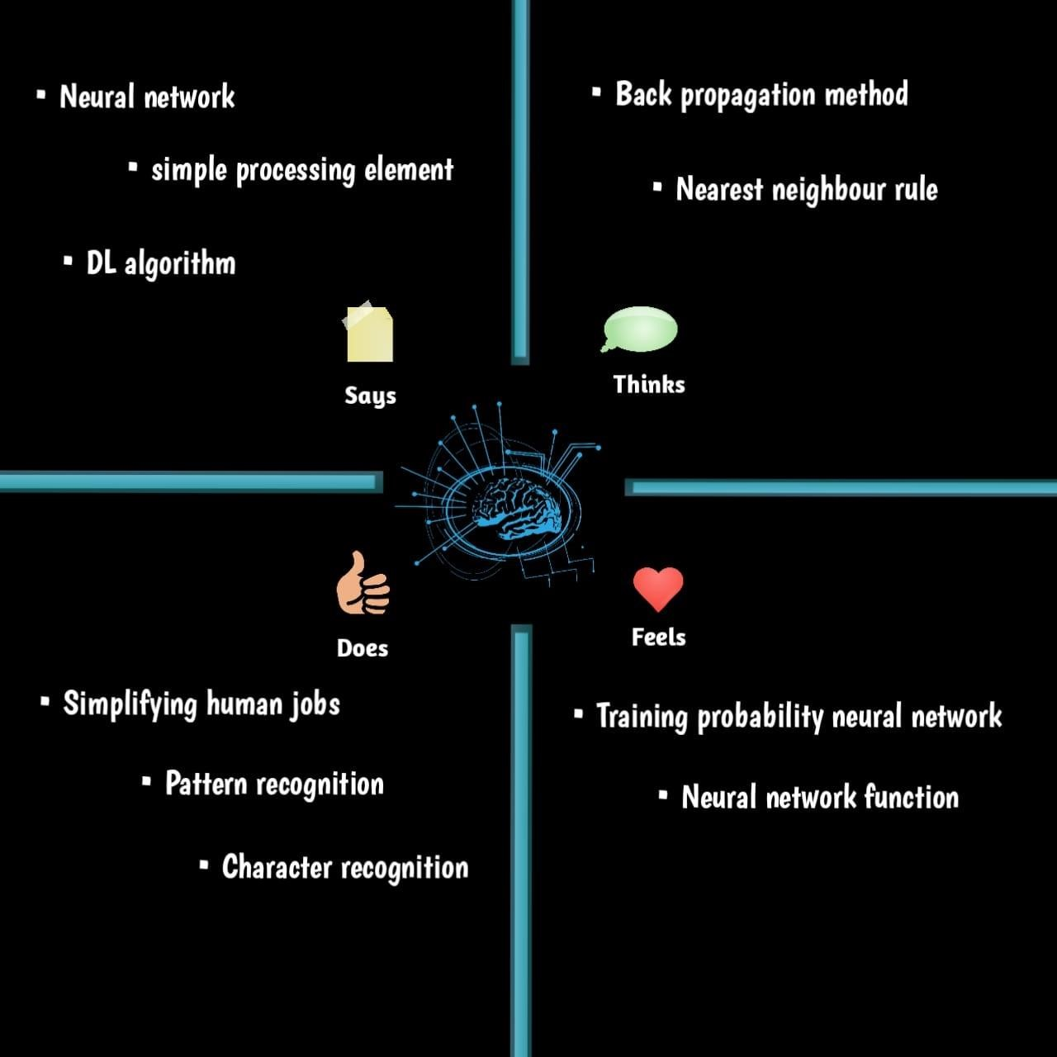

**Ideation**

**CUSTOMER SEGMENT :**

Customers who deal with handwritten numbers include banking industries, educational institutions, and other railroads, businesses, etc

**JOBS-TO-BEDONE/PROBLEMS :**

Sometimes it might be challenging to read and understand handwritten numbers. When working with, it could result in mistakes. sloppy writing

**TRIGGERS :**

To rapidly and precisely collect the statistics.

**AVAILABLE SOLUTIONS :**

There are no widely used programmes that can read handwriting; instead, they confirm the number with other people

**CUSTOMER CONSTRAINT(S) :**

They think that the alternatives will cause mistakes,accidents and inconvenience

**BEHAVIOUR :**

Finding the finest software to more quickly and accurately recognise digits

**CHANNELS OF BEHAVIOUR :**

Use online available software. Enlisting the aid of individuals in the area in order to identify the numbers that their clients have written

**PROBLEM ROOT CAUSE :**

Due to varying written pattern and the lack of optical characters identification provided by this inquiry,we counter many difficulties while attempting to recognise handwritten numbers.As a result,we can compare various techniques

**YOUR SOLUTION :**

Hand written digits evolution system, which employs a photograph of a digit existing in the image convolutional neural network model belt with 5% MNIST dataset

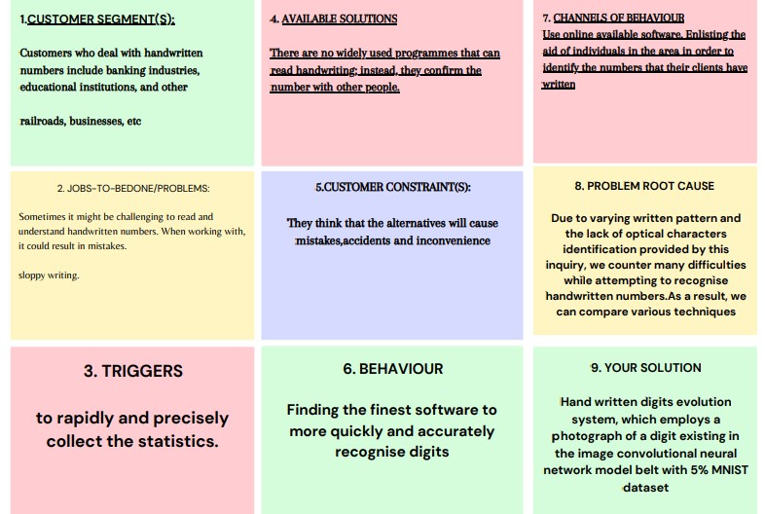

Problem Statement

|  |  |  |  |  |  |
| --- | --- | --- | --- | --- | --- |
| **Problem Stateme nt (PS)** | **I am (Customer)** | **I’m trying to** | **But** | **Because** | **Which makes**  **me feel** |
| PS-1 | Shopkeeper | Interpreting Hand written shopping list | Unable to figure out various names and data | Human  writing pattern differs ,at times unable to figure the meaning out | Irritation |
| PS-2 | Drug store Cashier | Following customer’s medicine list | Unable to do repetitive work | Manual work  is high | Distress |
| PS-3 | Finance advisor | Process the cheques | Manual error is high | It contains delicate numbers | Anxious |
| PS-4 | Event organiser | Sort the requirements of clients | Can’t understand the digits | It includes different styles | Disappointed |

PROJECT DESIGN PHASE 1

**PROPOSED SOLUTION;**

|  |  |  |
| --- | --- | --- |
| **S.No.** | **Parameter** | **Description** |
| 1. | Proposed Statement (Problem to be solved) | In this world, digit recognition is more important. It is capable of solving increasingly difficult problems and making humans jobs easier. Handwritten digit recognition is one example. This is a worldwide system for recognizing zip codes or postal codes for mail sorting. Handwritten digit recognition can be accomplished using a variety of approaches. The solution to this issue is handwritten digit recognition, which uses an image of a digit and identifies the digit represented in the image. |
| 2. | Idea / Solution Description | Handwritten digit recognition is performed using the MNIST dataset which contains 60,000 training images of handwritten digits from zero to nine and 10,000 images for testing. So, the MNIST dataset has 10 different classes. In this project, we are going to implement a handwritten digit recognition application trained using the Convolutional Neural Networks model. where the user gives the handwritten digit as input, where it is recognized and the result is displayed immediately |
| 3. | Novelty / Uniqueness | This project introduces an operative strategy for dealing with novelty in the handwritten visual recognition domain. A perfect transcription agent would be able to distinguish known and unknown characters in a picture, as well as determine any aesthetic variations that may occur inside or between texts. The existence of novelty has shown to be a major stumbling block for even the most robust machine learning-based algorithms for these activities. Novelty in handwritten papers might include, among other things, a change in the writer, character properties, writing attributes, or overall document appearance. Instead of examining each element separately, we believe that an integrated agent capable of processing known characters and novelties concurrently is a |

|  |  |  |
| --- | --- | --- |
|  |  | superior technique. The handwritten digit recognition problem can be seen as a subtask of the optical character recognition (OCR) problem |
| 4. | Social Impact / Customer Satisfaction | There are many benefits associated with the handwriting recognition system. In addition to reading postal addresses and bank check amounts, it is also useful for reading forms. Furthermore, it's used in fraud detection because it makes it easy to compare two texts and determine which one is a copy. As a result, this system fulfills customers' expectations, as it is a novel method for recognizing handwritten digits, ensuring high accuracy for the model and meeting all customer expectations. Users will save a lot of time and effort if the system provides various synonyms for the words recognized. Due to the fact that the users in rural areas will be using their own regional language, this proposed system should be able to detect those digits as well. As the system is being used in socially crowded places such as banks to check amounts, it should be fast and reliable. As it is designed to solve real-world problems, it should be highly reliable and trustworthy in every way, and users throughout the world should be able to use it effectively |
| 5. | Business Model (Revenue Model) | A revenue model means understanding how a startup can make money. Our major revenue sources consist of sales, government funds, and public donations. The introduction of novel ideas increases revenue streams, such as introducing gesture or touch features , voice read out of recognised digits, etc.. |
| 6. | Scalability of the solution | One of the approaches to make the handwritten digit recognition system scalable is to make use of cloud-native methods. For example, one of the cloud solutions for making AI scalable is IBM Cloud. IBM Cloud Build helps run and manage AI models, optimize decisions at scale across |
|  |  | any cloud. The advantage of using cloud to make solutions scalable is that we can deploy our AI application on |

**PROBLEM SOLUTION FIT**

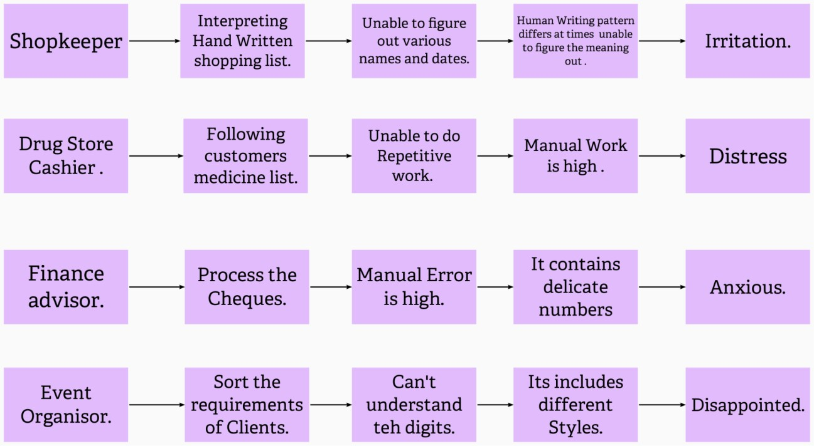

**Solution Architecture :**

**TECHNICAL ARCHITECTURE**

**SAS**

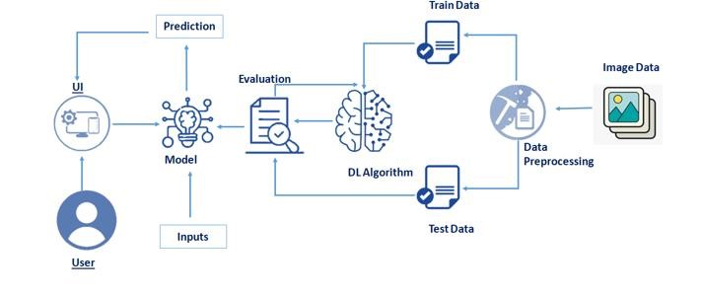

**MNIST Dataset Description :**

**SOLUTION ;**

There are 60,000 training and 10,000 testing handwritten digit images in the MNIST Handwritten Digit Recognition Dataset. Per image is 784 (2828) pixels in size and has a height and width of 28 pixels each. A single pixel value links every pixel together. It tells whether a pixel is bright or dark (larger numbers indicates darker pixel). This pixel value is a handwritten digit image with an integer value between 0 and 255.

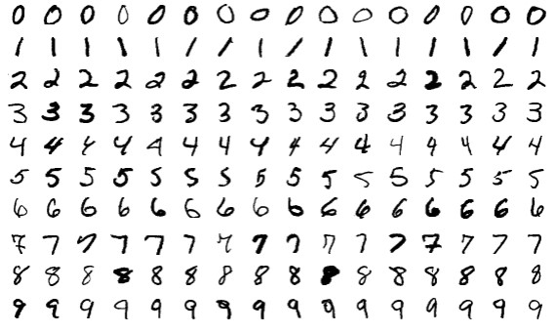

**PROCEDURE:**

Install the latest TensorFlow library.

Prepare the dataset for the model.

Develop Single Layer Perceptron model for classifying the handwritten digits.

Plot the change in accuracy per epochs.

Evaluate the model on the testing data.

Analyse the model summary.

Add hidden layer to the model to make it Multi-Layer Perceptron.

Add Dropout to prevent overfitting and check its effect on accuracy.

Increasing the number of Hidden Layer neuron and check its effect on accuracy.

Use different optimizers and check its effect on accuracy.

Increase the hidden layers and check its effect on accuracy

A dataset that is frequently used for handwritten digit recognition is MNIST.

10,000 test photos and 60,000 training images make up the dataset.

Artificial neural networks, which are a crucial component in the field of image processing, can most closely resemble the human brain. Using the MNIST dataset, handwritten digit recognition is a significant effort that was created with the use of neural networks.

In essence, it recognises the scanned copies of handwritten numbers.

We've gone a step further, and our handwritten digit recognition technology not only reads scanned photos of handwritten numbers, but also enables you to write numbers on the screen and have them read by an integrated GUI.

**APPROACH**

This project will be approached utilising a three-layered neural network.

**The input layer:** It transfers the characteristics from our example layers to the following layer so that the subsequent layer's activations can be calculated.

**The hidden layer:** These ties for the network are built up of hidden units known as activations. Depending on our needs, there can be a variety of concealed layers.

**The output layer :** The nodes in this layer are referred to as output units. It gives us access to the neural network's final prediction, which may be used to make final predictions.

**METHODOLOGY:**

We built a neural network with 100 activation units (but not bias units) and one hidden layer. A.mat file is used to load the data, after which features (X) and labels (Y) are extracted. The characteristics are then scaled down to a range of [0,1] and split by 255 to prevent calculation overflow. 10,000 testing cases and 60,000 training examples make up the data. The training set is used to derive the hypothesis, and backpropagation is then utilised to lessen the error between the layers. Overfitting is prevented by lowering the regularisation parameter lambda to 0.1. To choose the model with the best fit, the optimizer is run 70 times.

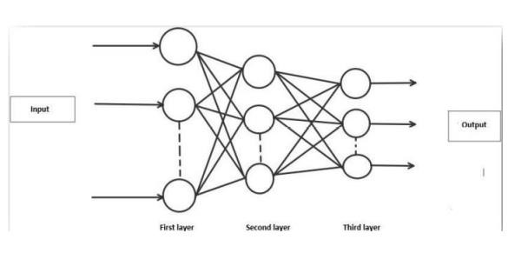

**ALGORITHM:**

**Forward Propagation Architecture:**

This is a succinct explanation of how the CNN module will extract features from the image and categorise it using those features. The design shows the input layer, hidden layers, and output layer of the network. Convolution and resampling are two of the many layers that are used in the network's feature extraction stage.

The user layer is the initial layer of the architecture, as explained by the example system. The users who engage with the programme and get the desired outcomes make up the user layer.

The frontend architecture of the application is made up of the following three levels. The application will be created on the open-source JavaScript, CSS, and HTML platform. The localhost, which is displayed in the browser, is where the programme is deployed. The user will be able to upload images of the handwritten numbers to the app to have them digitalized.

The business layer, which consists of logical calculations based on the client's request, sits between the database and view layers. It also includes the service interface

The backend layer consists of two datasets: Training Data and Test Data. The MNIST database has been used for that which is already divided into training set of 60,000 examples and test of 10,000 examples.

The training algorithm used is Convolution Neural Network. This will prepare the trained model which will be used to classify the digits present in the test data. Thus, we can classify the digits present in the images as: Class 0,1,2,3,4,5,6,7,8,9.

**WORKING :**

**Convolution Layer:**

The foundational component of a CNN is the convolutional layer. The parameters of the layer are a set of learnable filters (or kernels) that cover the entire depth of the input volume but have a narrow receptive field. Each filter is convolved across the width and height of the input volume during the forward pass, computing the dot product between the filter entries and the input to create a two-dimensional activation map of that filter. As a result, the network picks up filters that turn on when they spot a certain kind of feature at a particular location in the input.

**Feature Extraction** :

Each neuron in a feature has the same weights during feature extraction. In this manner, the same feature is recognised by all neurons at various locations in the input image. Limit the number of unrestricted parameters.

**Layer for Subsampling:**

Reducing the overall size of a signal is referred to as subsampling, sometimes known as down sampling.Each feature map's spatial resolution is decreased by the subsampling layers. Shift or distortion invariance is attained, and the impact of sounds is lessened.

**Pooling layer:**

In a Convent architecture, it is typical to sporadically introduce a Pooling layer between subsequent Conv layers. In order to decrease the number of parameters and computation in the

network and, as a result, control overfitting, it gradually shrinks the spatial size of the representation. The Pooling Layer functions separately on

**TensorFlow :**

TensorFlow is a free machine learning package that may be used for both study and production. TensorFlow provides developers of all skill levels with APIs for desktop, mobile, web, and cloud applications. To get started, refer to the sections below. We can achieve text output and sound output by scanning the number digit and converting it to png format using the python3 command in terminal.

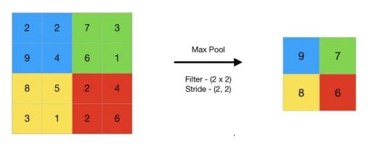

**RESULTS:**

We do not consider our results to be flawless after processing, as with every study or effort in the field of machine learning and image recognition. There is always space for improvement in your method because machine learning is a topic that is constantly developing. Additionally, there will always be new approaches that yield better results for the same problems. The application was sent in Multi-Layer Perceptron (MLP), Convolution Neural Network (CNN), and Network models were employed (CNN). Depending on the model that shows which is best, the classifier's accuracy varies.

PROJECT DESIGN PHASE 2

**Customer Journey Map :**

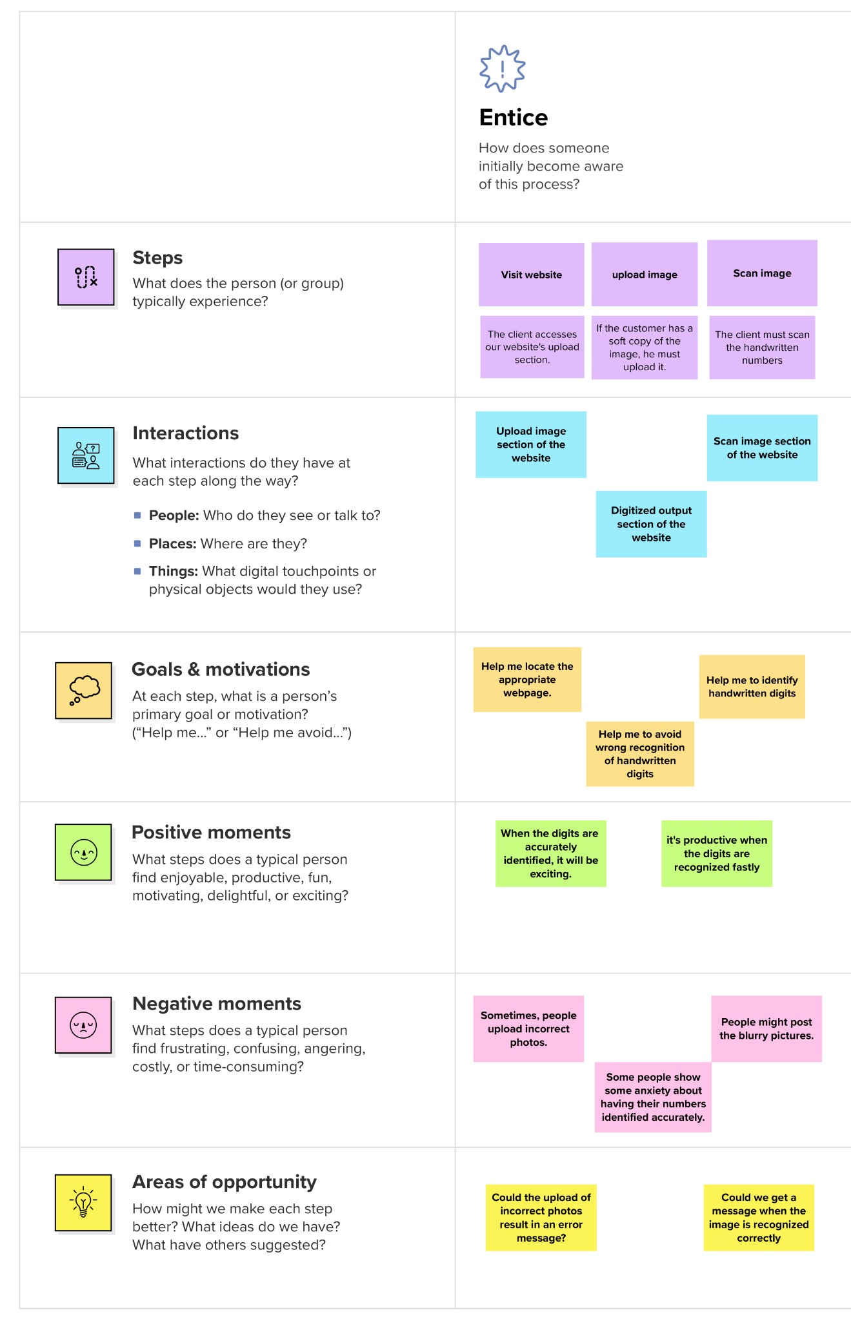

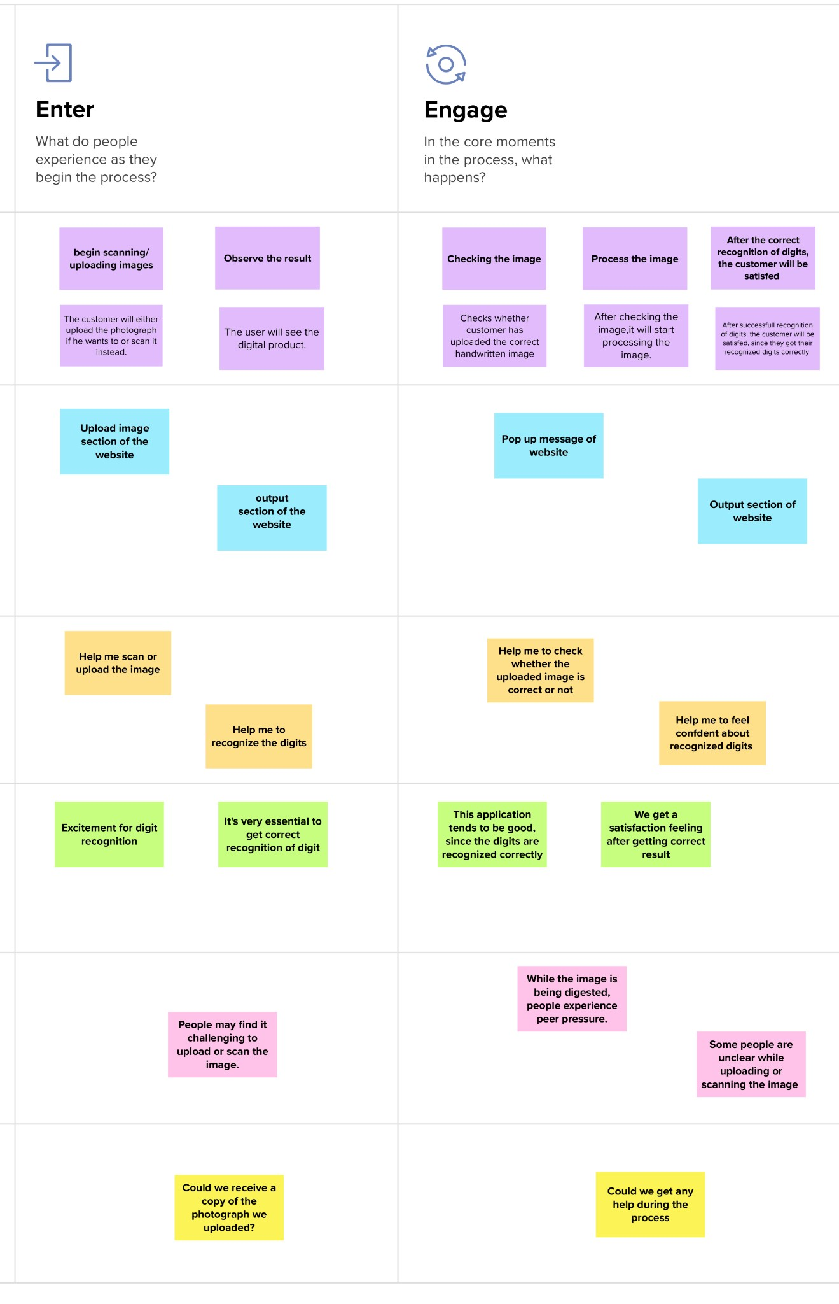

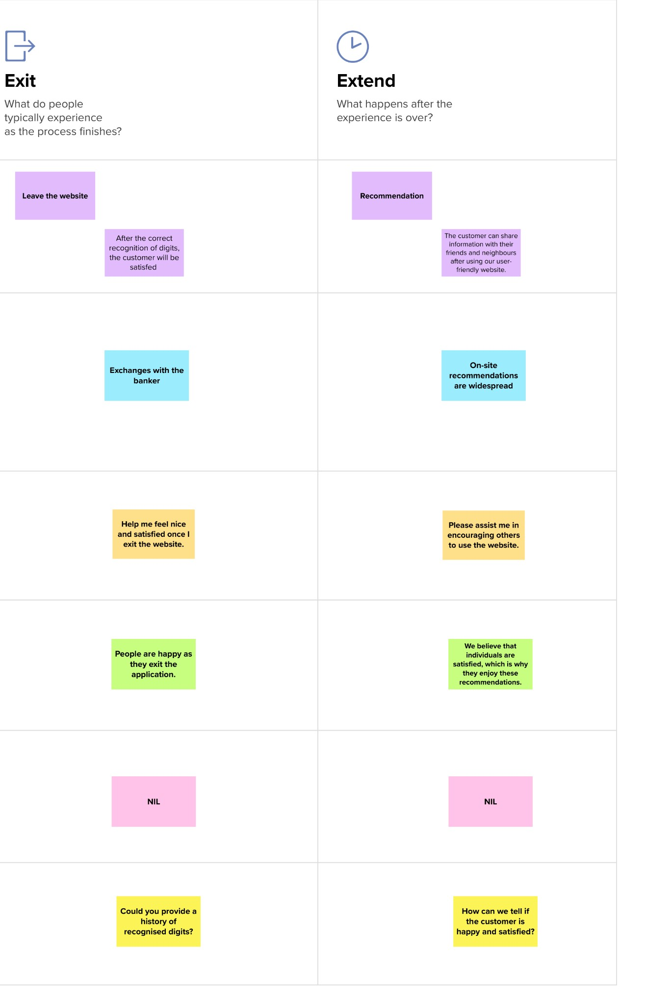

**Solution Requirements :**

**Functional Requirements:**

Following are the functional requirements of the proposed solution.

|  |  |
| --- | --- |
| **FR No** | **Sub Requirement (Story / Sub-Task)** |
| FR-1 | Image Data: Handwritten digit recognition is the ability of a computer to recognise human handwritten digits from a number of sources, including pictures, papers, touch screens, etc., and classify them into ten predetermined categories (0-9).  This has been the focus of innumerable studies in the field of deep learning. |
| FR-2 | Website: Web hosting enables online access to the HTML, graphics, and other components of a website. Every website you've ever visited is hosted by a server. The amount of server space provided to a website depends on the hosting type. The four primary types of hosting are shared, dedicated, VPS, and reseller. |
| FR-3 | Use the MNIST database of handwritten digits to train a neural network to predict the digit from a picture. assemble the data for training and validation first. |
| FR-4 | Cloud: The cloud provides a variety of IT services, such as server, database, virtual storage, networking, and servers. Cloud computing is defined as an internet-based virtual platform that allows for limitless data storage and access. |
| FR-5 | modified dataset from the National Institute of Standards and Technology The shorthand for  The MNIST dataset is referred to as MNIST. The images are 60,000 minuscule square grayscale photos, each measuring 28 by 28, with scrawled single digits from 0 to 9. |

**Non-functional Requirements :**

Following are the non-functional requirements of the proposed solution.

|  |  |  |
| --- | --- | --- |
| **FR No** | **Non-Functional Requirement** | **Description** |
| NFR-1 | Usability | The recognition of handwritten characters is one of the major issues with pattern recognition applications. The processing of bank checks, filling out forms, and sorting mail are a few uses for digit recognition. |
| NFR-2 | Security | In addition to classifying the digit, the system also gives a full description of the instantiation parameters, which could reveal details like the writing style.  Segmentation powered by recognition is a capability of the generative models. 3) A relatively is used in the process. |
| NFR-3 | Reliability | The neural network applies the samples to automatically determine handwritten digit reading rules. Increasing the number of training cases will also help the network understand more about handwriting and improve its accuracy.  Handwritten numbers can be recognised using a variety of methods and algorithms, including Deep Learning/CNN, SVM, Gaussian Naive Bayes, KNN, Decision Trees, Random Forests, etc. |
| NFR-4 | Accuracy | Optical character recognition (OCR) technology provides accuracy rates of more than 99% for typed text in high-quality pictures. Less accurate character identification is caused by spacing variations, handwriting anomalies, and the diversity of human writing styles. |
| NFR-5 | Availability | The availability of this function will be highly dependable upon the features requirement |

**Data Flow Diagrams :**

A Novel Method for Handwritten Digit Recognition System

**User Stories :**

|  |  |  |  |  |  |  |
| --- | --- | --- | --- | --- | --- | --- |
| **User Type** | **Functional Requireme**  **nt (Epic)** | **User**  **Story**  **Number** | **User Story / Task** | **Acceptance**  **criteria** | **Priority** | **Release** |
| Customer  (Web  User) | Home | USN-1 | I can upload the image that needs to be identified as a user | I can select an image from the system's local storage. | High | Sprint - 1 |
| Customer  (Web  User) | Home | USN-2 | I can identify the uploaded image using the application feature as a user. | I have access to the output. | High | Sprint - 2 |
| Customer  (Web  User) | Home | USN-3 | I can obtain the input image that has been processed as a user. | I may download the output to the system storage locally | Low | Sprint - 3 |

**Technology Stack :**

**Technical Architecture :**

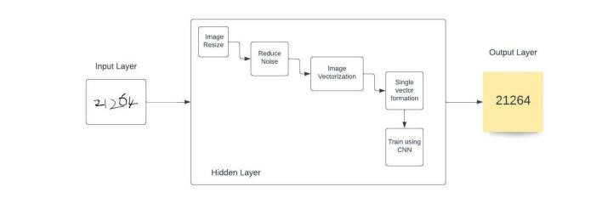

**Table-1 : Components & Technologies:**

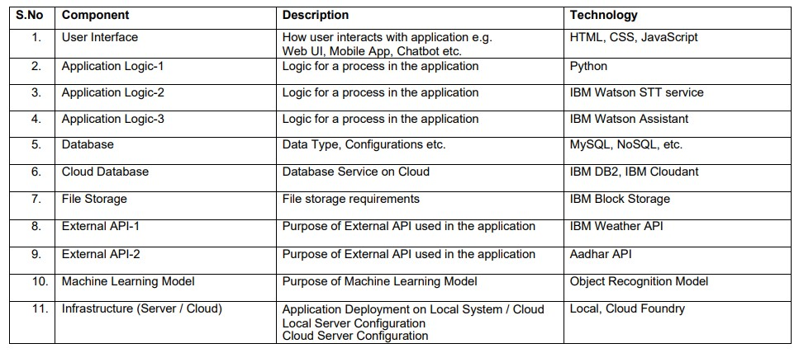

**Table-2: Application Characteristics:**

|  |  |  |  |
| --- | --- | --- | --- |
| **S.No** | **Characteristics** | **Description** | **Technology** |
| **1.** | Open-Source Frameworks | There is a list of the open-source frameworks utilised. | The technology of  Opensource framework |
| **2.** | Security  Implementations | a list of all the security and access controls,firewalls, etc.,that have been used. | SHA-256, Encryptions, IAM Controls, OWASP |
| **3.** | Scalable  Architecture | to support the system's architecture's ability to scale.Easy to use and very adaptable | 3 – tier, Micro-services |
| **4.** | Availability | Abstract and figures. The ability to recognise handwritten digits has been put into practise.Based on shape analysis, these characteristics extract slope or slant information from the digit picture.They succeed in getting excellent recognition accuracy. | Distributed servers, IBM cloud |
| **5.** | Performance | Using common neural network implementations,the handwritten digits are correctly categorised with an accuracy of (98–99) percent. | number of requests per sec, use of Cache, use of  CDN’s |

PROJECT PLANNING PHASE

**Prepare Milestone and Activity List**

**Project Tracker, Velocity & Burndown Chart: (4 Marks)**

**JIRA SOFTWARE DASHBOARD OF THE PROJECT:**

[**https://pnt2022tmid10088.atlassian.net**](https://pnt2022tmid10088.atlassian.net)

**Velocity:**

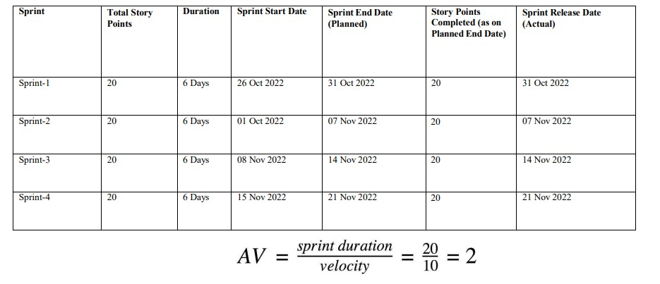

**Imagine we have a 10-day sprint duration, and the velocity of the team is 20 (points per sprint). Let’s calculate the team’s average velocity (AV) per iterationunit (story points per day)**

**Burndown Chart:**

**A burn down chart is a graphical representation of work left to do versus time. It is often used in agile software development methodologies such as Scrum. However, burn down charts can be applied to any project containing measurable progress over time.**

**Sprint Delivery PLAN**

Project Tracker, Velocity & Burndown Chart: (4 Marks)

JIRA SOFTWARE DASHBOARD OF THE PROJECT:

<https://pnt2022tmid10088.atlassian.net>



**Velocity:**

Imagine we have a 10-day sprint duration, and the velocity of the team is 20 (points per sprint).

Let’s calculate the team’s average velocity (AV) per iterationunit (story points per day)

**Burndown Chart:**

A burn down chart is a graphical representation of work left to do versus time. It is often used in agile software development methodologies such as Scrum. However, burn down charts can be applied to any project containing measurable progress over time.